CPSC 349: Front-End Web Engineering - Fall 2021

Homework 2, done by 17 Sep 2021

In this assignment, you will work through Chapter 7 of the textbook (Visual Effects with CSS) to add JavaScript to your Ottergram project.

Complete the following:

- Work through Chapter 7. As you make changes to main.js, verify that you see error messages reported by ESLint (for example, try leaving off a semicolon).

- Confirm that clicking each thumbnail changes the detail image and title to match.

- Add previous (<) and next (>) buttons on either side of the detail image. Use the buttons to cycle back and forth through thumbnails and corresponding detail images and titles.

- Push the contents of your project to a new GitHub repository. Do not push this assignment to the same repository as Homework 0 and Homework 1.

Submission

Turn in the code for this homework by uploading your project to a public repository on GitHub. While you may discuss this homework assignment with other students, you must complete the work on your own.

To complete your submission, print the following sheet, fill out the spaces below, and submit it to the professor in class by the deadline. Failure to follow the instructions exactly will incur a 10% penalty on the grade for this assignment.

CPSC-349 17 Sep 2021 page 1 of 2

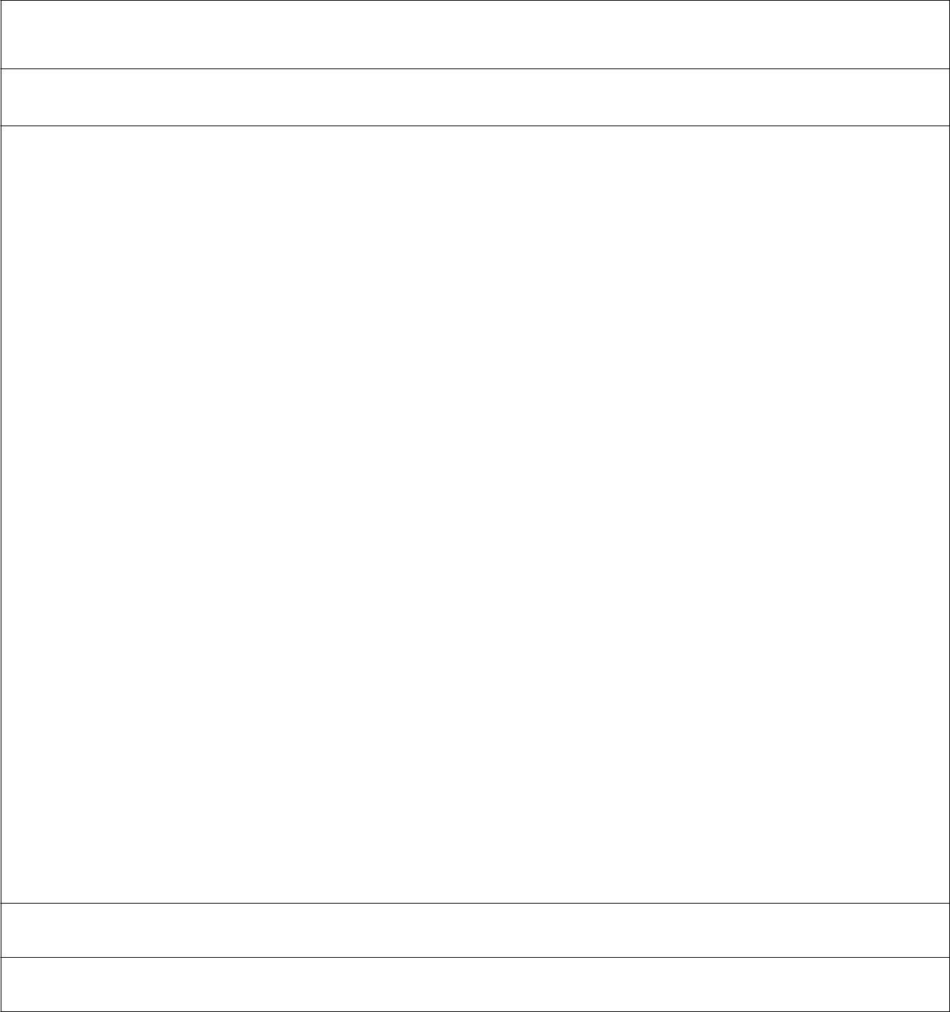
CPSC 349 Homework Submission 2, due 17 Sep 2021

Your name: Evan Le

Repository (print): https://github.com/le11evan/CPSC349_Ottergram_HW2

https://github.com/le11evan/CPSC349_Ottergram_HW2

Verify each of the following items and place a checkmark in the correct column. Each item incorrectly marked will incur a 5% penalty on the grade for this assignment

Finished |  | Not
 |  | finished
□ |  | □ | Ottergram page is seen at http://localhost:3000 when browser-sync is running
□ |  | □ | There is a scripts/ folder containing main.js.
□ |  | □ | Clicking a thumbnail changes the detail image and title to match the thumbnail.
□ |  | □ | Clicking < and > cycles left / right through thumbnails, detail images, and titles
□ |  | □ | No warnings are shown in Visual Studio Code when editing HTML or CSS code.
□ |  | □ | No error messages appear in the browser’s DevTool’s console.
□ |  | □ | HTML, CSS, and JavaScript code have been reformatted with atom-beautify
□ |  | □ | The Project directory has been pushed to the above GitHub repository
Comments:

Fill out and print this page, and submit it on the day this project is due.

CPSC-349 17 Sep 2021 page 2 of 2

